Click on collection and add a request then give the name as Enviroment variable

.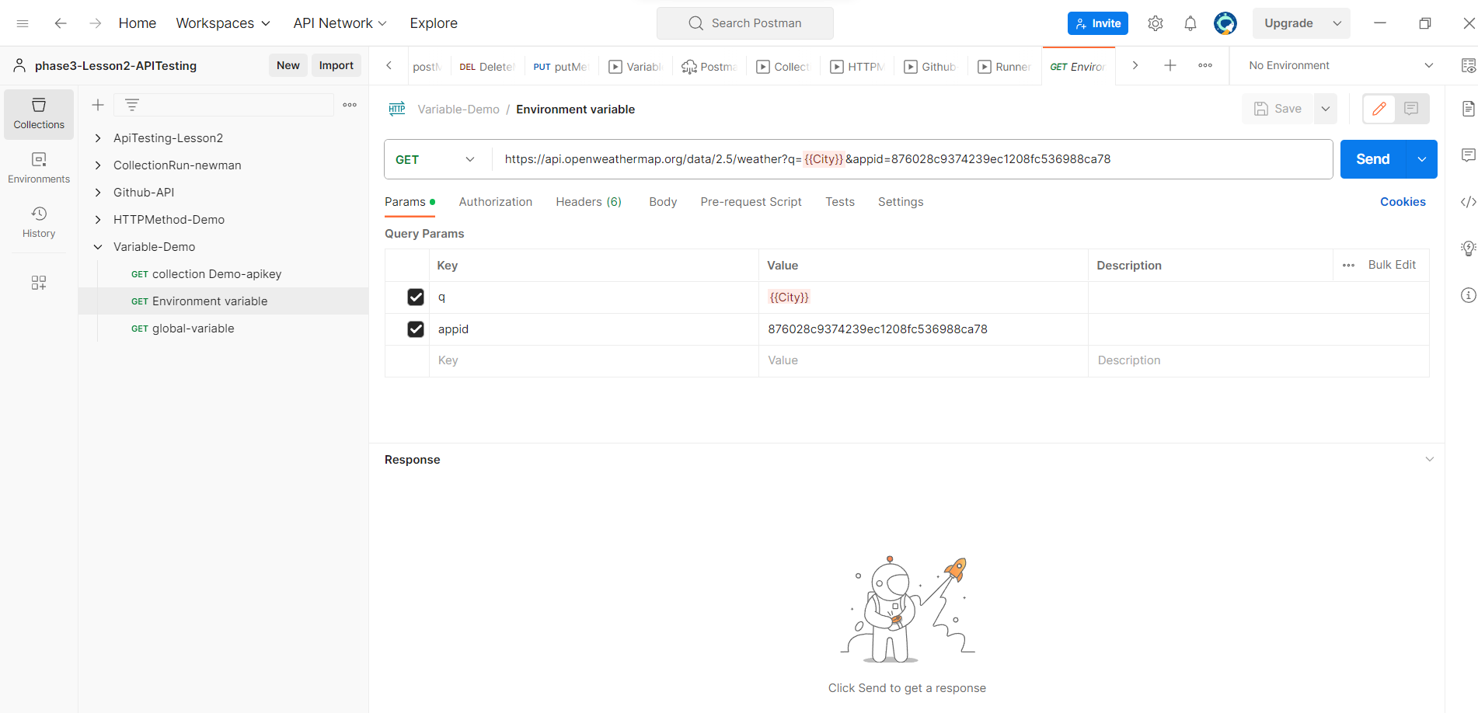

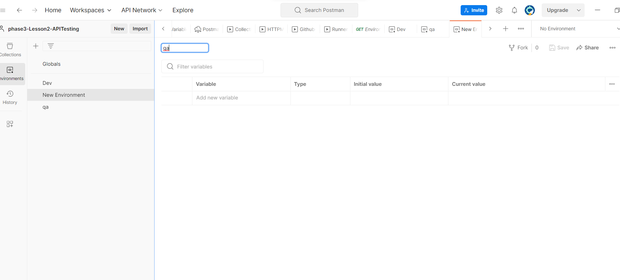

Enter the variable in enviroment

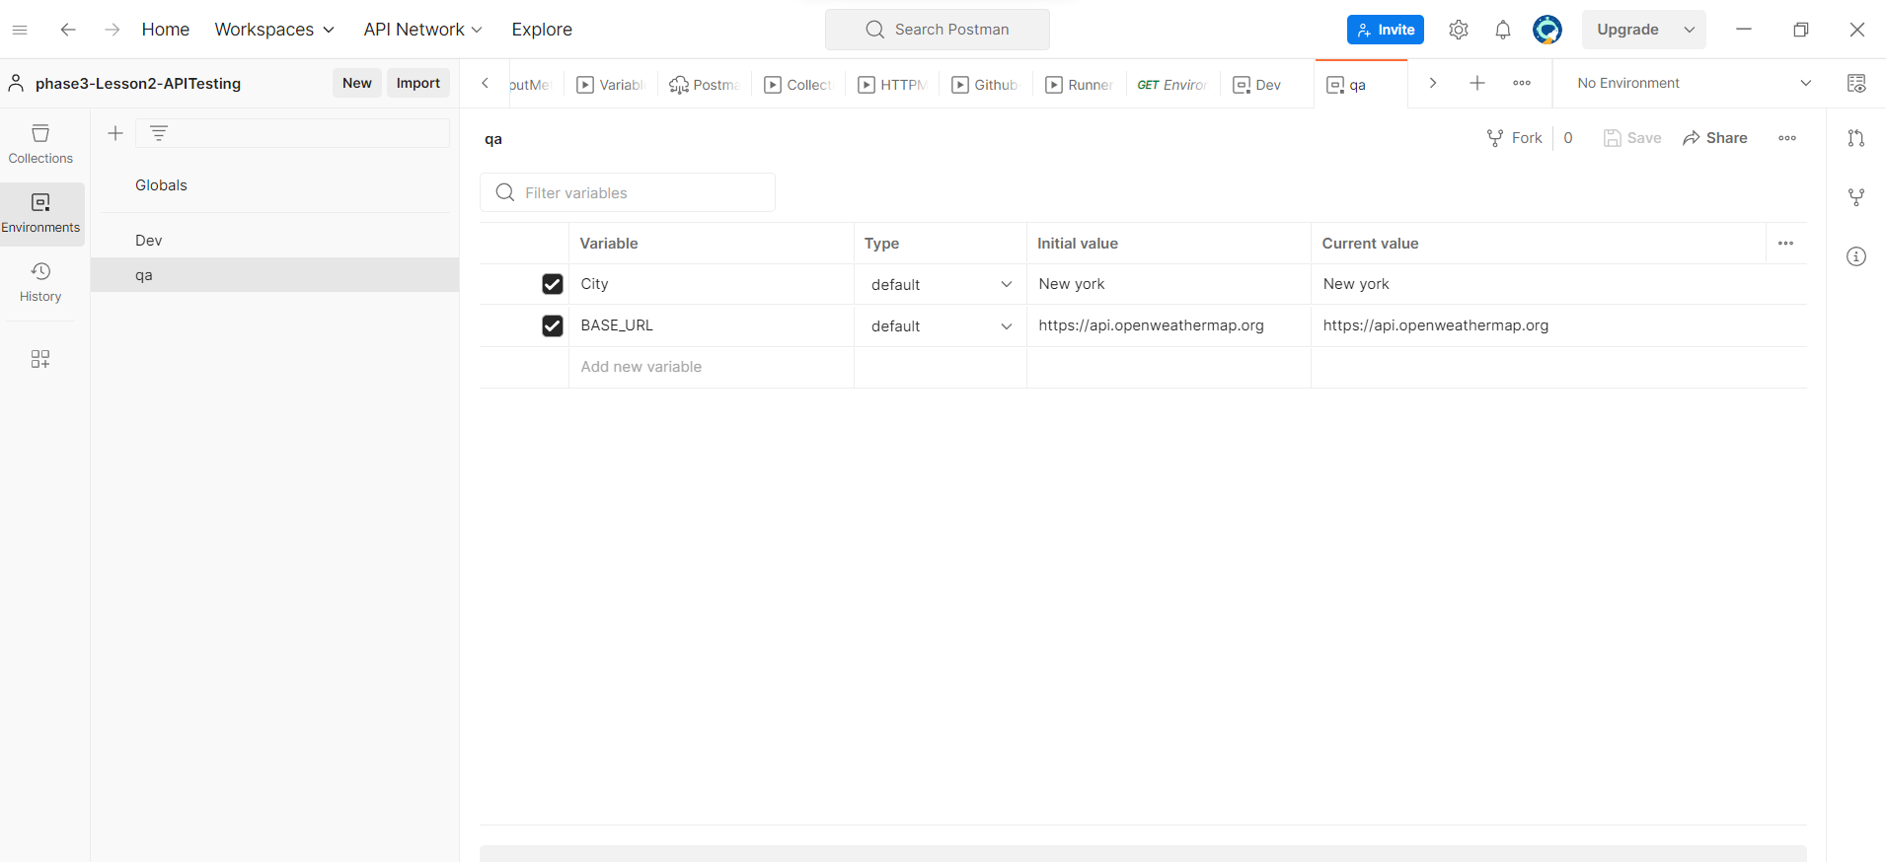

Then create a add request to collection

Then give the name to the request

Then select the method

Enter the url

Call the environment variable

Select the environment variable top right side of the screen.

Then save the request

Click on run button to see the result

